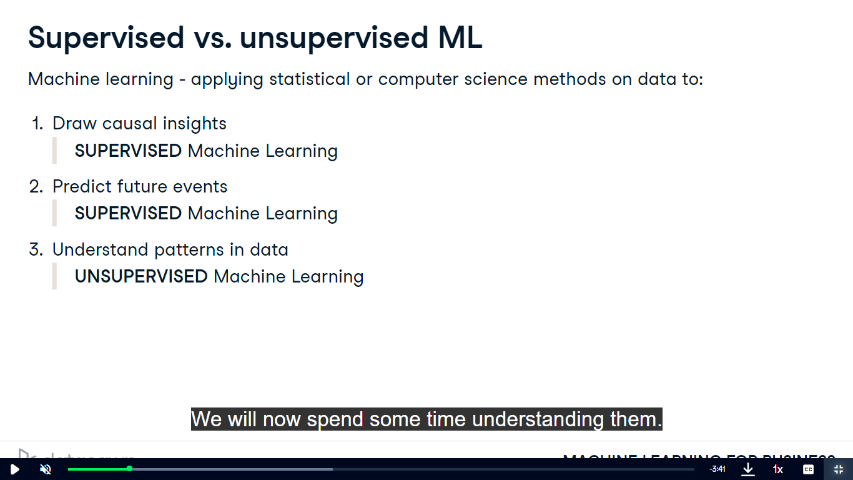

print(prod_types['duration'].str.replace(" min",""))